README

Star Wars: Edge of the Empire dice roller is a bare bones roller for the Fantasy Flight Games (FFG) latest RPG. It is a very simplistic setup. Create the dice pool for the roll by entering the numbers next to each type of die. Select whether you want the dice roller to Autoreduce the result (Autoreduce will cause Failures to cancel Successes, Threats to cancel Advantages). Then click “Roll Dice”. The result of the roll will be posted in the box above the minor notes. They will be clustered together so that all the Advantages are next to each other, all the Failures, etc…

Special Notes: Triumphs and Despairs also count as a Success or Failure respectively. This is already accounted for in the program, so if a Triumph (T) is shown, but no Success (s) is shown, then a Failure cancelled out the Success; Same thing with a Despair (D) and its Failure (f).

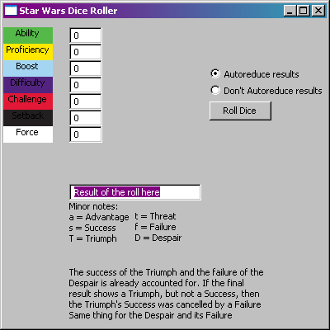

Figure : Default look of the application at launch

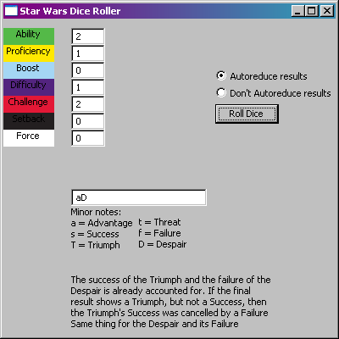

Figure : Result of a roll with Autoreduce enabled. Note that the Despair (D) doesn't show a Failure (f)

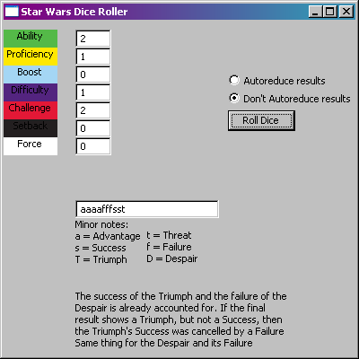

Figure : Result of a roll with Autoreduce disabled. Notice that the Successes and Advantages haven't been reduced by the resulting Failures and Threats